The Chartered Management Institute
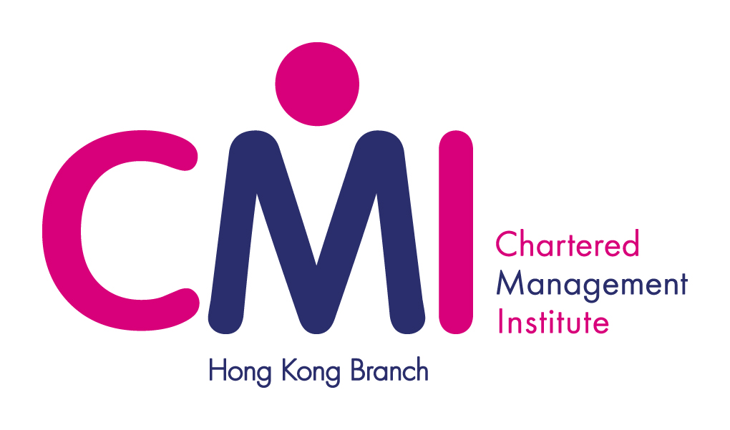
Hong Kong Branch

Inspiring Leaders’ Series
“IS MANAGEMENT INNOVATION DEAD?”
by Dr. Michael Y. K. Chan,
Executive Chairman of Café de Coral Holdings Limited

Synopsis:
For the past century, people have worked in the management prisons of the Industrial Age, which has focused on an efficiency-centric, bureaucracy-based management system.

This current management model no longer suffices in a world where adaptability and creativity drive business success.

True management innovations are never bound by what is, instead they dream of what could be. The challenge is to reinvent our management systems so they inspire human beings to bring all of their capabilities to work every day, creating a company of community, creativity and sense of purpose.

Unfortunately, no one expects managers to be innovators. Rather, they are selected, trained, and rewarded for their capacity to deliver more of the same, more efficiently.

Are we then witnessing the death of management innovation?

Guest Speaker: Dr. Michael Y. K. Chan Ph.D. (Hon.), M.C.P., B.A., M.C.I.P., M.H.K.I.P., H.K.I.M. (Hon.), F.A.I.B.A, F.C.I.M.
Dr. Michael Y. K. Chan is the Executive Chairman of Café de Coral Holdings Limited, which currently is the largest publicly listed Chinese quick service restaurants group around the world. Being the strategic driving force behind the Group, Dr. Chan manages a total of over 530 restaurant units all over the world covering territories in the United States, Canada, Hong Kong and China.

Under Dr. Chan’s 25 years of management leadership, his group of Companies have received numerous local and international management awards, which include The Asian Management Award for Marketing Management, the Business Excellence Award, the Best Employers in Hong Kong Award and the Leader in Corporate Governance. On a personal basis, Dr. Chan was awarded with the most coveted Stars of Asia Award, the prestigious Executive of the Year Award, the Bauhinia Cup Outstanding Entrepreneur Awards, the Hong Kong Business Mastermind Award, the Directors of the year Award, and more recently the Ernst & Young Entrepreneur of the Year.

Dr. Chan holds a double major Degree in Sociology and Political Science, Master Degree in City Planning with distinction and scholarship from the University of Manitoba, Canada. He was also awarded a Honourary Doctorate Degree in Business Administration by an American University as well as a Court Member and Honoree, Beta Gamma Sigma of the Hong Kong University of Science and Technology. More recently, he was again being bestowed with the honor as Honourary Fellow of Lingnan University.

Dr. Chan is also a very active member of the community as he serves on the executive committee of the Retail Management Association, the general committee of the Employers' Federation of Hong Kong, the appointed member of Quality Tourism Services Association as well as a council member and Fellow of the Hong Kong Management Association. Moreover, he is also appointed by Hong Kong Special Administrative Region as member of the Provisional Minimum Wage Commission as well as member of the Hong Kong Tourism Board.

Co-sharing Guest: Dr. Peter C. F. Wong Ph.D, FCMI
With over 25 years of operations and management experiences gained from world prestigious hotel companies. Dr. Wong is currently General Manager of Royal Plaza Hotel and V.P. - Operations for Royal Plaza Hotel, Royal Park Hotel and Royal View Hotel. Amongst his many credentials including a Ph.D. from Bulacan State University, Dr. Wong also serves as Chairman of Institute of Hospitality (Hong Kong Chapter), Executive Committee Member of HKHA and Fellow Member of HKIoD and FCMI.

The Chartered Management Institute
Hong Kong Branch

Date: Thursday, 9th September 2010
Time: 7:00p.m. Reception
7:30p.m. Programme Starts
Venue: Royal Plaza Hotel, 193 Prince Edward Road West, Mongkok, Kowloon
Fee: HK$280.00 for CMI Member, Friends of CMI(HK) and Members of Supporting Organisations
HK$350.00 for Non-member
Language: English
CPD Hour: 2 CPD hours
Registration:
Please fax/email/post the Reply Slip and post the cheque to the Secretariat on or before Tue, 31 Aug 2010. Reservation is on a first-come-first-served basis.

Programme:
- Reception
- Inspiring Leaders’ talk by Dr. Michael Chan
- Sharing Session:
Dr. Michael Chan
Dr. Peter Wong
Moderator: Dr. Joseph Tsui
- Dinner
- End of Event

Location Map:

Supporting Organisations:

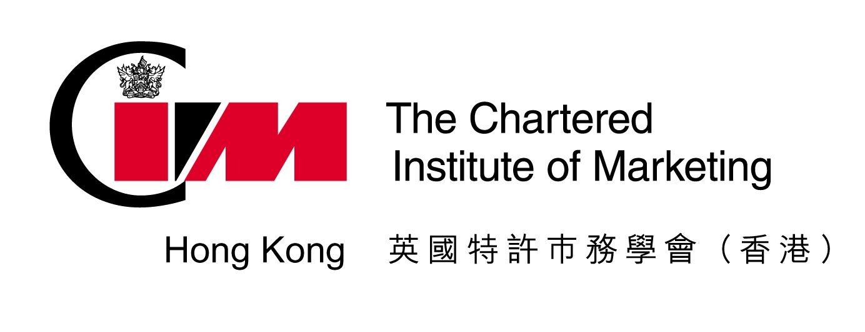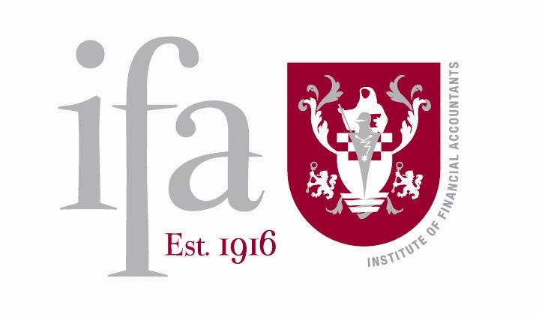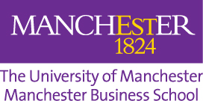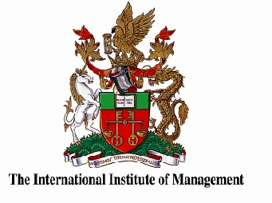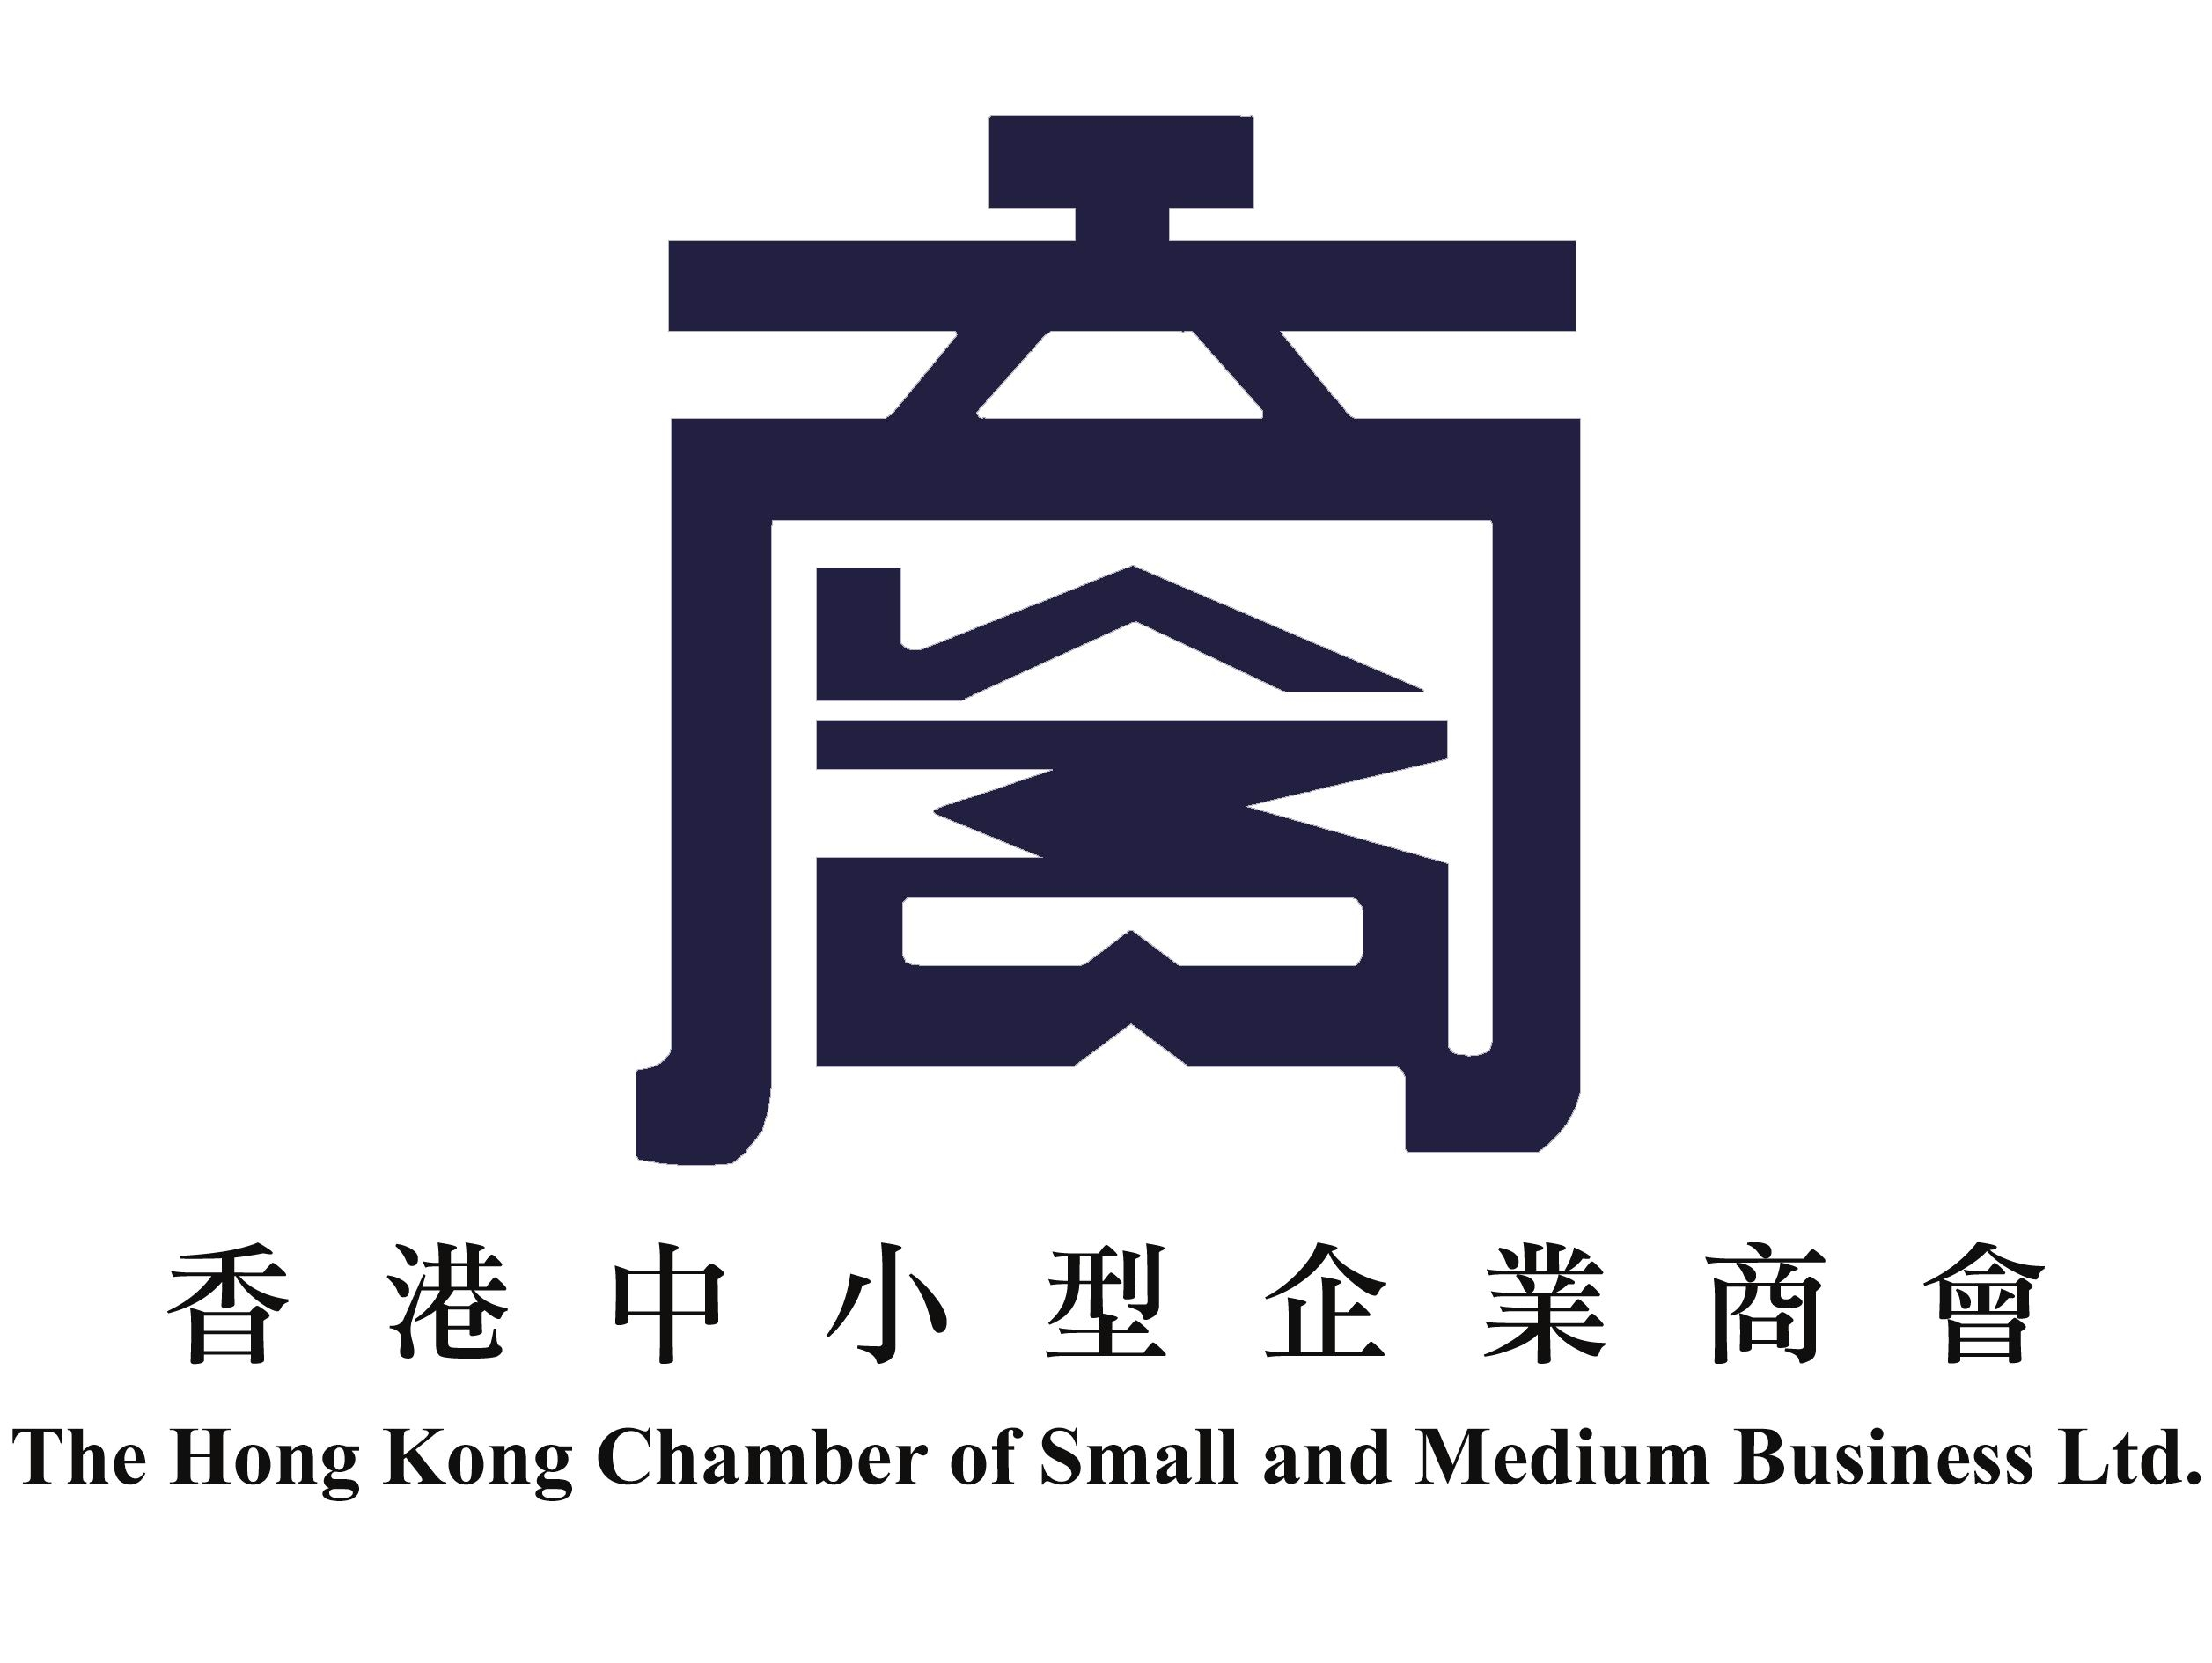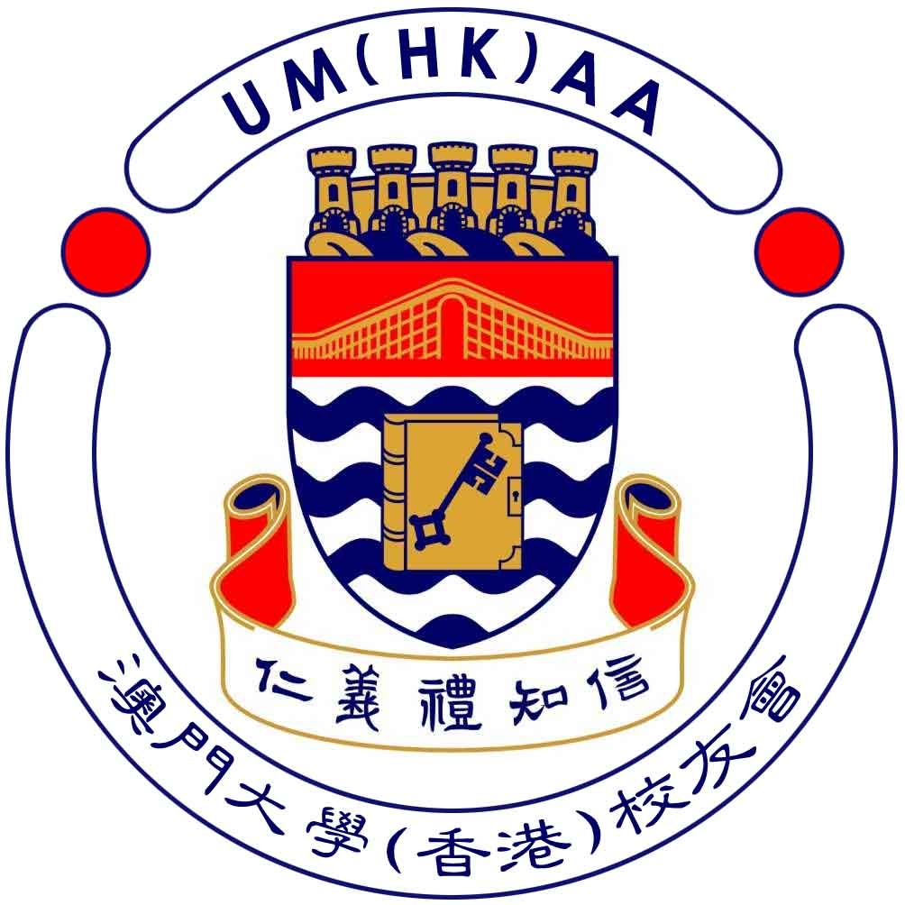

The Chartered Management Institute
Hong Kong Branch

REPLY SLIP

Inspiring Leaders’ talk cum dinner
Thursday, 9 September 2010

I would like to reserve _____ seat(s) for ___ no. of Member/___ no. of friends of CMI(HK) / & ___ no. of members of Supporting Organisation/___no. of Non-member, and enclosed the cheque for HK$_____________ for joining the event.

Cheque should be payable to the “The Chartered Management Institute, Hong Kong Branch”

Name | CMI-HK Membership No.  /Supporting Organisation | Contact No. | E-mail

Please send reply slip with cheque to:

The Chartered Management Institute – Hong Kong Branch
Room 801
Hing Lung Commercial Building,
68 Bonham Street East
Sheung Wan,
Hong Kong

For any enquiries, please contact Secretariat Office:

Tel: 2111 2782 Fax: 2111 2783 E-mail: info@managers.org.hk

